|  |
| --- |
| PROPOSAL AND MARKETING PLAN  The Civic Conference & Business Centre |
| South Ribble Borough Council |



[http://seth/sorce/configs/banner/welcome_area_logo.png](http://www.southribble.gov.uk/)

## The Civic Conference & Business Centre Business Plan

### **Contents**

Project summary…………………………

The Proposal ……………………………….

Resources …………………………………….

Our Vision …………………………………….

Marketing Proposal ………………….

Project Partners …………………………

Financial projection ………………….

#### Project Summary

Following the completion of the Phase 1 project, which has seen the complete overhaul of The Civic Conference & Business Centre, this plan is to propose the Phase 2 works, which will allow The Civic to operate as its own entity. It will remove the need for the main council offices and reception to be open and accessible during weekend and evening bookings, allow delegates accessing The Civic to enter via a dedicated, modern and professional entrance.

Upon entry, attendees will have the option to check in for their appropriate meetings, or should they not have a meeting booked, they can opt to use the free space, utilising the self-service coffee machines, integrated USB charge points and free Wi-Fi.

It is our aim to provide a business hub, central to South Ribble which will offer meeting and communal space for informal meetings. It is hoped, the increased footfall within The Civic, will then lead to increased sales and revenue generation from the paid space.

We wish to provide businesses with a space that is modern, bright and suitable for both internal and external meetings that need to be held away from their primary location. As it stands currently, businesses have the choice of The Leyland Hotel or Large Franchise Coffee houses to facilitate this need.

Additional benefits offered by The Civic include, large free onsite carpark, reduced rate room hire for community and charitable organisations, centralised location with excellent transport links & dementia and disability friendly location for all.

#### The Proposal

Please see below the initial proposed plan for The Civic entrance and the new coffee shop style area.

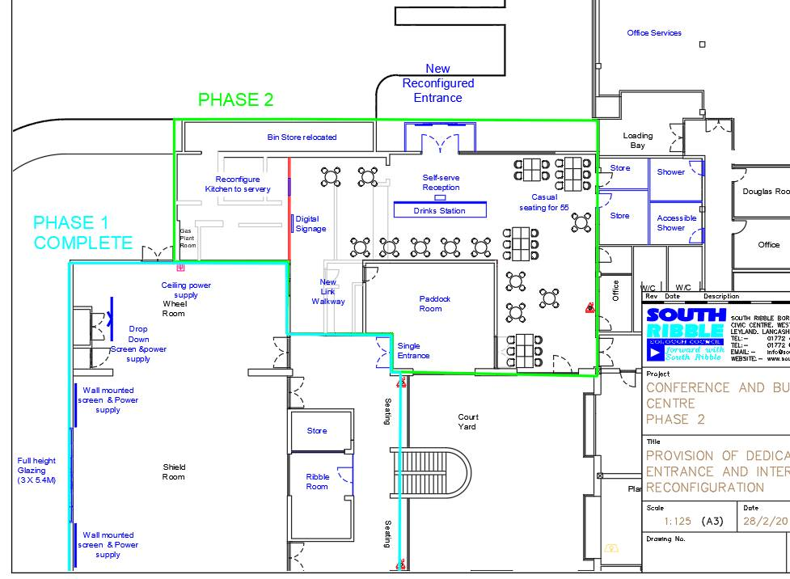

As the area marked for development, must still fulfil its civic requirements to host council and cabinet meeting meals, the redesign must accommodate seating for up to 55 council members and have the facility for hot meals to be served on these occasions. With this in mind, it is proposed that the seating area consist of smaller seating groups accommodating 2, 4 or 6 people maximum to a table. The seats will be varied and include standard high back chairs as well as bar stool seating along the wall at a countertop and also plush couches and arm chairs for those wishing to relax.

The space will be open to members of the public during the day, as well as to members of staff as an additional break out area to that created during the 3rd floor redevelopment.

Our initial market research suggests, that businesses require a space to host informal meetings without the added stress of room hire costs and bookings. They also require a venue that is easy to reach, clearly signposted, in a central location, with good parking facilities, Wi-Fi and a professional atmosphere.

The Civic offers all these, but the current building layout requires businesses to park on the rear carpark, walk to the front of the building and enter via the main council entrance, which is also used by DWP visitors, as well as local residents. This can be a negative factor for some businesses, along with the close ties this draws to the conference & business centre being a council operated venue.

Following discussions with several high street franchised coffee distributors, we are looking to provide the best possible option available for refreshment services. The cost to the council must be minimal and where possible cost neutral. Discussions are already underway with coffee distributors regarding free lease agreements for the equipment on the basis of return on investment via stock reorder. A cost analysis will take place once 3 quotes are available for this and a comparison drawn between the available refreshment options.

It is also envisaged, that in time as visitor numbers increase, we hope to work closely with a local catering supplier on a sale or return basis for small quantities of ready to eat meals and sweet treats. This again, will provide visitors and staff with low cost menu items that will not cost The Civic in the event of no sale. In order for this to be considered in the future, a clear increase in visitor numbers must be demonstrated, with a direct correlation between visitor numbers and the sale of refreshments and increased room hire revenue.

#### Resources

* Furniture to compliment the redesign
* Refreshment station that is self-service, minimising staff involvement
* AV equipment, directing delegates to appropriate meeting rooms as well as advertising council events and notices
* Firmstep online calendar booking add-on to allow both internal and external visitors to check room availability and book appropriate meeting space. This will also allow for the option of payment by card at the time of booking, reducing the number of unpaid invoices that are having to be chased for payment.
* Space appropriate kitchen equipment

#### Our Vision

Establish The Civic Conference & Business Centre as a high-quality brand, offering a ‘brand standard’ in line with the council’s priorities. A great location for meetings and conferences and promote South Ribble as the ’place to do business’.

The Civic Conference & Business Centre offers a range of flexible meeting spaces, together with an excellent front of house customer service, putting our customer’s requirements at the heart of everything we do.

We aim to work with our local charities and community groups by offering meeting space at discounted rates when available.

#### Marketing proposal

The marketing strategy detailed below is underway and will continue whilst the physical alterations to the Civic Centre happen, enabling a seamless transition when the new entrance is opened, with increased visitor numbers immediately.

It is imperative that The Civic remains contemporary and competitive, to become the preferred venue for businesses in and around South Ribble. In the local area there is only one setting which currently caters to the small business meeting demands; businesses wishing to enjoy a drink in a welcoming and professional environment where they can take small meetings away from their main hub of operations. For events such as this, organisations are limited to supermarket café’s, small high street coffee shops, out of town venue’s or the one setting previously mentioned. None of these options are ideal for various reasons and it is planned that ‘The Civic’ can help fill this gap in the market and bring increased numbers into the venue, some of whom may look to hire the meeting rooms or spaces. Key to this will be the provision of high-quality free Wi-fi for people using the new facility and accessible USB power sockets for devices.

A comprehensive review of how our space compares in the marketplace is being undertaken. This analysis includes understanding changing demands of the average business user and the facilities important to them, placing emphasis on client expectations and requirements, and their perception of our competitiveness.

It will be vital for the continuing financial viability of ‘The Civic’ that it is well used for most of the time it is open. This will not necessarily happen automatically, and it will be essential to have in place, an effective marketing strategy. This will need to address the following principles:

• Maximising benefits created by the location, appearance and range of facilities;

• Creating a professional/corporate image;

• Creating an atmosphere in ‘The Civic’ that is fully inclusive and attractive to people of all ages, backgrounds and interests.

To appeal to the business users in the local community, the following strategies are proposed to maximise usage:

• Holding introductory/open days and other events to generate interest.

• Promoting an active relationship with local press and media and advertise the activities & events in local business directories.

• Carrying out surveys at regular intervals in order to judge changing needs.

• Creating and maintaining an effective presence on the Council’s website and links to other professional sites.

• Ensuring that hire charges and facilities remain competitive in comparison with other venues in Lancashire

• Connect with various Lancashire based networking event organisers to promote the use of The Civic for networking events, bringing a wide variety of businesses into the venue and demonstrate the facilities available.

#### Project Partners

Local businesses, SRBC teams and External partners:

* Facilities Management Team
* Communications Team
* Projects Team
* Stone Create – Marketing & Website Design
* External Caterers
* Auditel AV Equipment
* External building contractors
* External decorator

#### Financial projection

Please see below current revenue figures for The Civic against budget.

|  |  |  |  |  |  |  |  |  |  |  |  |  |
| --- | --- | --- | --- | --- | --- | --- | --- | --- | --- | --- | --- | --- |
| **Income v's Budget** | | | | | | | |  |  |  |  |  |
|  | Actual 2019/20 | Budget 2019/20 | Actual 2018/19 | Budget 2018/19 | Actual 2017/18 | Budget 2017/18 |
| Room Hire | 19805 | 9500 | 20115 | 12000 | 36213 | 27900 |
| Food Sales | 1686 | 2300 | 545 | 2300 | 1707 | 2300 |
| Total | 21491 | 11800 | 20660 | 14300 | 37920 | 30200 |
| Actual as a % of budget | 182.13% |  | 144.48% |  | 125.56% |  |

It is proposed that the coffee shop style facilities, as well as the dedicated entrance and improved aesthetics of the centre will bring increased footfall within The Civic, and should therefore see a steady increase in the year on year revenue generated.